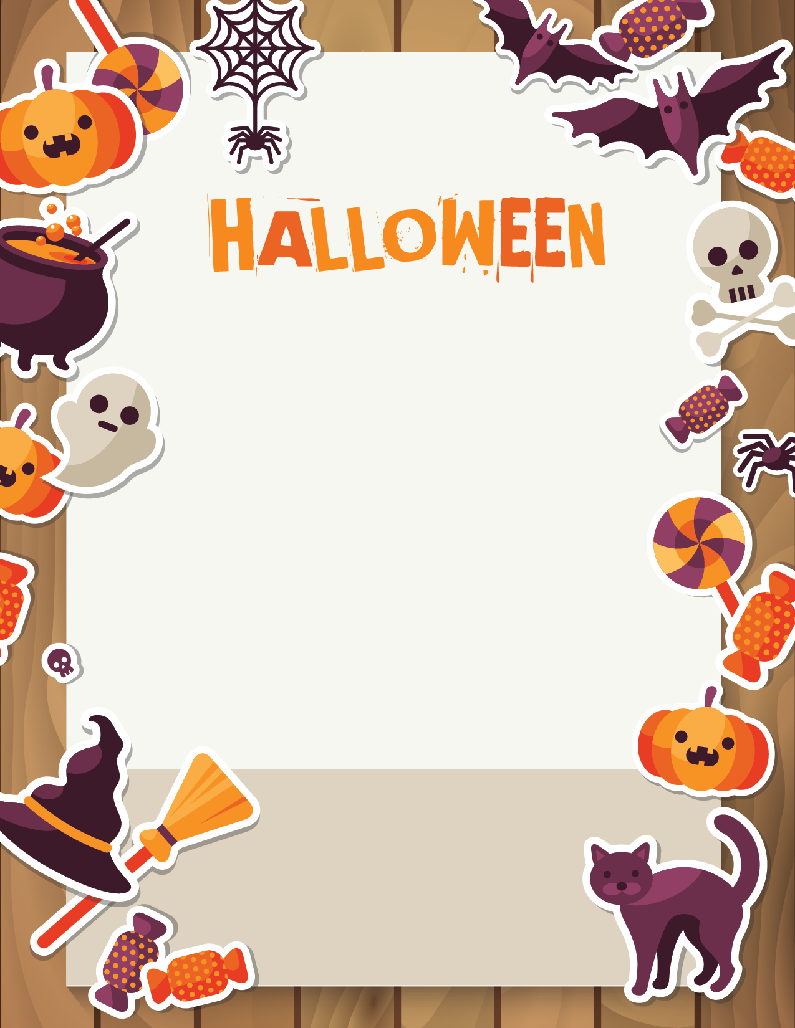­­­­

Join us for a fun Trunk or Treat event! It will be a night of fun including games and Trunk or Treating.

Families, we need to know how many to expect so please send in the bottom portion to school to let us know to expect you! Also, if you are participating by decorating your trunk and giving out candy, please complete the section below and send it in to us. *We are also accepting candy donations for the event, so please send that into the office.* More information will be coming home soon with a detailed agenda of the event.

**Come dressed in your favorite costume!**

______ Yes, I will be decorating a car trunk and

giving out candy.

______ Yes, my family is participating in the event

and will be bringing ________ people.

______ Yes, I would like to help work at a station.

____________________________ Student’s Name

____________________________ Parent’s Name

Please RSVP by Friday, October 25th.

**Trunk or Treat**

**Tuesday, October 29th**

6:00-7:00 pm

*\*\*Students must be supervised by Adults at all times.\*\**